Scripts for Scene: **ControlRoom_RIGHT**

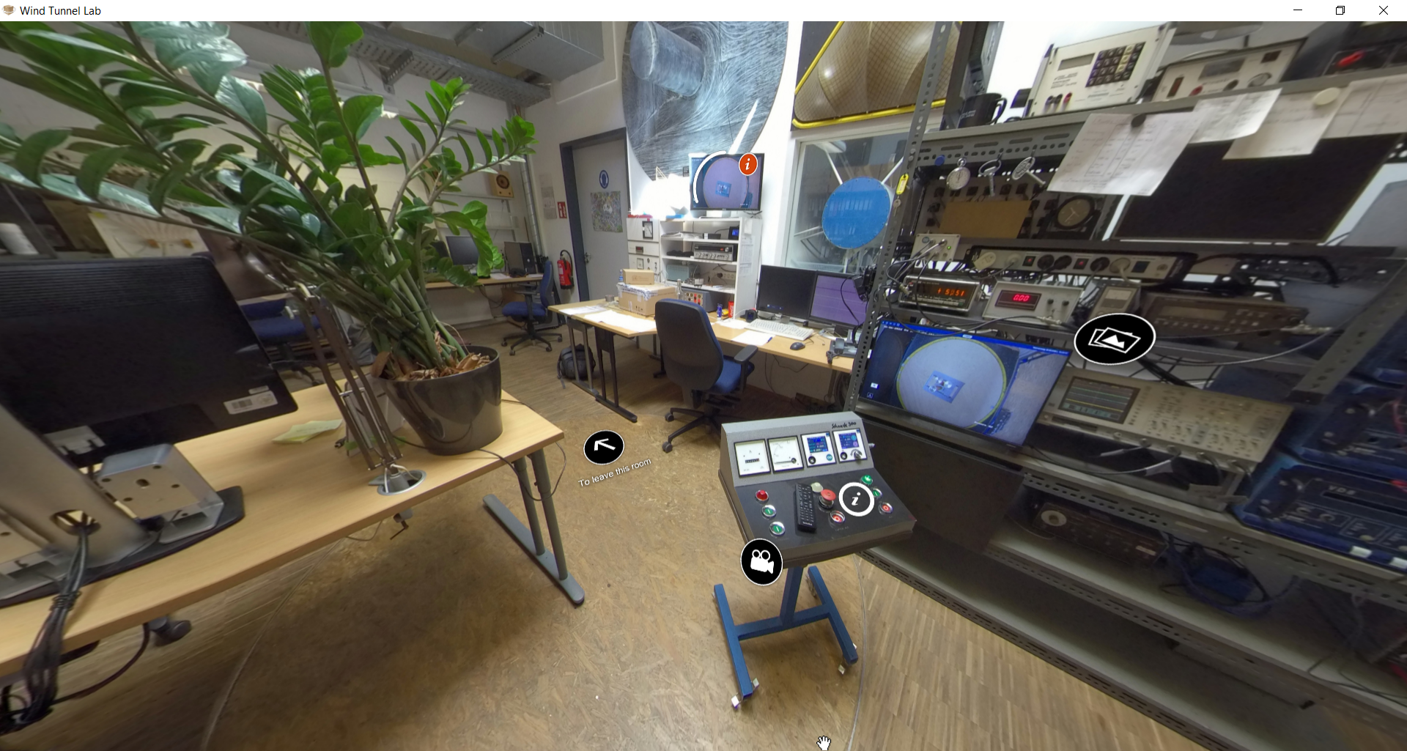

|  |  |  |
| --- | --- | --- |
| Nr | Hotspot (see red arrow) | Script |
| 1 | Hotspot: Monitoring screen | Figure+Text  Figure :    Text :  During the experiment, the model or test structure can be observed visually through the monitoring camera system. Sometimes, when the oscillations due to wind are large enough to be observed by eyes, plausibility check between the recorded signal and the observed oscillation can be made. This will help the researcher to better plan and perform the experiments. |
| 2 | Hotspot: Control board/station | Slided Text and Video (separated in two hotspots, see image on the left):  Slide-1 Text:  The control board/station is used to start and stop the operation of the wind tunnel, as well as to set the wind speed of the wind flow. The operation of this control station is usually done by the technician.  Slide-2 Text:  The wind speed can be indicated by the engine rotation, which is displayed in angular frequency (ω) unit RPM and general frequency (f) unit Hz. 1 Angular frequency ω equal to 2πf.  Slide-3 Text:  Usually, in the experiment with wind speed, the researcher who sits in front of the monitor will ask the technician for a frequency (in RPM or Hz). After that, the technician would decide whether the engine rotation is stable and give a notice to the researcher, so that they can start the measurement/recording of the data. |
| 3 | Hotspot: PC and S-Bench Software for the recording of the measurement: | Slided Figure and Text +Video (Album)  Slide-1 Figure:    Slide-1 Text:  This is the PC to monitor the measurement in Wind Tunnel. Not only that, but the measurement is also recorded by using a software called S-Bench that is installed in on this PC.  Before a wind tunnel experiment is conducted, the programmed script for S-Bench and channels for each sensor must be configured. The S-Bench is initiated through a command prompt, by running the programmed script.  After the S-Bench is loaded to the screen, measurement or data recording can be started by pressing the green arrow symbol on the left.  The measurement will last depend on the period set in the programmed script. After the measurement has finished, "Ready" will be shown, and the measurement must be saved, by clicking the green arrow on the right side of the screen.  For the signal monitoring, the display of the oscilloscope is duplicated to the second monitor, so that the researcher can also monitor parallelly. (See Video in the later slide)  The monitoring of the real-time signal through the oscilloscope is important to observe whether the signal is plausible or not.  Slide-2 Figure:    Slide-2 Text:  In the process of measurement and recording of the data, one must follow the three processes: 1. First reference measurement, 2. The real measurement, 3. Second reference measurement. The reference measurement of *Nullmessung* is a short measurement where there is no wind existing and situation are stable. Two reference measurements must be conducted at the before and after the real measurement. The procedure has been automatically arranged to be conducted in the script which commands the procedure of measuring/recording the data.  Slide-3 Video (No text):  File name: “Signal-monitoring.MOV” |
| 4 | Hotspot: Electrical and Oscilloscope station | Slide Figures/Album + Video (with text):  Slide 1-Figure :    Slide-1 Text:  On the most-right side of the control room, measurement equipment and its electrical component are available. Electrical equipment that are used in the process of measurement such as amplifier, oscilloscope, measurement cards, power supply, voltmeter, multimeter and more. The equipment may be not easily seen in the related figure. Second monitoring scene is also available, so that the technician or second person available can also view the model in the wind tunnel from the control room.  Slide-2 Figure:    Slide-2 Text:  The figure shows the computer workstation which connects to the monitor of the computer shown in the same room. The workstation/computer has 8 measurement cards, where each of the card has 16 channels. The total 128 channels for sensors are provided. This means, in the concept, the 128 sensors can be run parallelly. Each channel refers to 1 voltage value/signal, which refers to 1 sensor to be recorded. The software S-Bench is used to regulate the measurement cards. The software is also used to load the computed script as the measurement command, to proceed with measurement and recording the data, and to set up the channels.  Slide-3 Video only:  File: “videos_messtechnik.mp4”  How the slide Figure is displayed: |
| 5 | Hotspot: Typical sensors used in the wind tunnel: Pressure sensor | Slided Figure+Text (Album):  Slide-1 Figure:    Slide-1 Text:  Pressure sensor to measure the incoming wind pressure is an important measurement method, where one can directly measure the wind pressure and relate its value to the wind load attacking the test structure. Generally, the choice of pressure sensor depends on the measuring range that one aims for. In the pressure measurement of the wind, the sensor must be able to measure the negative pressure as suction is experienced by the structure when vortex is shed.  Slide-2 Figure:    Slide-2 Text:  As one of the pressure sensors that are usually used in the WISt Wind Tunnel of Ruhr-University Bochum, pressure sensor Honeywell 170 PC is elaborated here. The pressure sensor consists of an opening on two sides, where a sensitive pressure cell/membrane is placed between the sides. For this example of sensor, it has measurement +/- 35 mbar. Technical specification can be seen in the later slide. (Source Figure: Koss, 2001)  Slide-3 Figure:    Slide-3 Text:  The sensor is usually placed outside of the model, due to narrow spaces in the model. This means that a tube is attached on the model in a small bore (e.g., 0.7-1 mm), which is then connected to one side of the sensor. The other side of the sensor is connected to reference pressure (e.g., the velocity pressure measured in Prandtl Tube). Therefore, the pressure sensor will measure the difference between the two sides, and it is able to measure the incoming wind pressure. The pressure sensor also has an electrical output which is connected to the electrical equipment and data acquisition system.  Slide-4 Figure:    Slide-4 Text:  Before conducting the experiment, calibration of the pressure measurement system must be done. The calibration can be done in two phases: static phase and dynamic phase. The static calibration  was performed to establish the pressure–voltage relation for each pressure sensor, while dynamic  calibration was performed to correct the dynamic effects of tubes (Quoted from Hemida et al., 2020, adapted from Neuhaus, 2010). Only static calibration will be explained in this virtual tour.  Slide-5 Figure:    Slide-5 Text:  The static calibration can be done by giving a specific value of pressure (e.g., 5 mBar) which can be monitored through Betz-Manometer. It is known that the pressure sensor type that is used from Honeywell has measurement range +/- 5V that relates to +/- 5 mBar. Therefore, by giving 5 mBar value the voltmeter which is connected to the measurement system should show absolute value of 5V. (Source Figure: Poufayar, 2017).  Slide-6 PDF File  File name: “0900766b8002e11f.pdf”  Slide-7:  References:  [1] H. H. Koss. Einfluß der Simulation des natürlichen Windes auf die Prognose des Überlastrisikos von Hallentragwerken (Dissertation). Ruhr-Universität Bochum, 2001.  [2] H. Hemida, A. S. Glumac, G. Vita, K. K. Vranesevic, R. Höffer. 2020. On the flow over high-rise building for wind energy harvesting: An experimental investigation of wind speed and surface pressure. Journal Applied Science, Vol. 10 Issue 15 5283.  [3] C. Neuhaus. Numerische Frequenzabhängige Kalibrierung Langer Druckmessschlauchsysteme. Technical report: Building Aerodynamics Laboratory. Ruhr University Bochum, 2010.  [4] T. Poufayar. Experimentelle Ermittlung von windinduzierten Oberflächendrücken zur statischen und dynamischenAnalyse von großformatigen Parabolrinnenmodulen. Master Thesis. Ruhr-Universität Bochum, 2017. |
| 6 | Hotspot: Typical sensors used in the wind tunnel: Force balance | Slided Figure+Text (Album):  Slide-1 Figure:    Slide-1 Text:  Force balance or force sensor is used to measure the force and bending moment that is resulted from the incoming wind load. In the focus of grouped cylinder experiment, only 6-Axis force/torque sensor is displayed in this virtual tour. The 6-Axis force sensor measure the force and moments in the three directions of space. This is very useful for a cantilever model such as a scaled model of steel chimney or wind turbine towers.  Slide-2 Figure:    Slide-2 Text:  The force balance or force sensor that is used in the grouped cylinder experiment is K6D40 500 N / 20 Nm from ME-Meßsysteme. The sensor housing is made from stainless steel. Quoted from the technical specification of the sensor for conciseness, the force is applied to an annulus / 6 segments of a circle, on the end faces of the sensor. A centering hole is provided to secure the angular position. This means that customized mounting devices need to be designed according to the model. Centering and positioning of the mounting is very important to obtain an accurate experiment result. In the next slide, technical specification of the sensor is provided.  Slide-3 PDF File:  File name: “6-Axis_Force_Sensor_K6D40_500N _20Nm_MP11_20221002.pdf” |
| 7 | Hotspot: Typical sensors used in the wind tunnel: Laser sensor | Slided Figure+Text (Album):  Slide-1 Figure:    Slide-1 Text:  Laser sensor or laser displacement sensor is used to measure the displacement by using the concept of reflection of the radiated laser light. When there is an object placed in front of the radiated laser light, the laser ray is blocked, and the ray is reflected back to the sensor. The distance between the object and the laser sensor can be then measured. Generally, two concept of the reflection of the laser ray is confocal method and triangular method. Confocal method sensors emit and receive the laser ray in the same axis. The triangular method sensors emit the laser ray, and when the laser ray is reflected, it is reflected in an angle to a different side on the sensor. (Source Figure: <https://www.keyence.eu/>, accessed on 2 October 2022)  Slide-2 Figure:    Slide-2 Text:  In the WISt Wind tunnel, the triangular laser sensor is used. As an example, one of the sensor is ILD1750-200 from Micro Epsilon manufacturer. This sensor has 200 mm measuring range. The minimum measuring range is 70 mm, and the maximum measuring range is 270 mm. This is an important parameter as a consideration to choose which laser sensor should be used. The measuring range should be compared with the expected oscillation of the investigated model. Other important parameters to be considered are the frequency of the sensor, input and output type, and the sampling rate. (Source Figure: Micro Epsilon)  Slide-3 Figure:    Slide-3 Text:  In the next slides, the technical specification of the sensor can be found.  Slide-4 PDF File:  File name: “dax--optoNCDT-1750BL—en.pdf” |
| 8 | Hotspot: General information about the electrical connection of sensor and the measurement computer | Figure + Text:  Figure:    Text:  In general, the sensors that are installed on the model will have the electrical output that is connected further to data acquisition system. This depends on which sensor is used, and whether the manufacturer of the sensor requires additional accessories for data acquisition process. Each sensor that are used in the experiments will be connected to computer with measurement cards. The measurement cards provide available channel slots for each sensor. Amplifier may also be needed be needed. General sequence from sensor to the recorded data can be seen in the figure. The path from the measuring point to the recorded value in the file must be unambiguous and traceable. For example, after the installation it is strongly suggested to check the measurement circuit by checking the tightness of the connections. |